**Introduction**

On-line e-Learning System is very much important for any Educational Organizations to prepare their students for any exams by saving the time. It will take check the paper and generate mark sheets as well. It will also help the Organization to test the students and develop their skills. But the disadvantages for this system are, it takes a lot of times when you prepare the exam at the first time for usage.

e-Learning exploits interactive technologies and communication systems to improve the learning experience. It has the potential to transform the way we teach and learn across the board. It can raise standards, and widen participation in lifelong learning. It cannot replace teachers and lecturers, but alongside existing methods it can enhance the quality and reach of their teaching, and reduce the time spent on administration. It can enable every learner to achieve his or her potential, and help to build an educational workforce empowered to change. It makes possible a truly ambitious education system for a future learning society.

On the other hand, pressure comes from policy makers, who recognize that “the complexity of the world today requires employees to have extensive knowledge and skills, more than at any other time, to meet the demands of industry and society.” [89] In the light of globalization governments see the necessity for a highly qualified workforce to enable their country to compete as a center of research and technology and as a business location on a global level.

## The effective use of "Learning Point", any Educational Institute or training centers can use it to develop their strategy for arranging the exams, and for getting better results in less time and better understanding.

**1.2 Purpose**

e-Learning purpose is important in implementing eLearning as it will help in producing great results if one knows how to use it. The key success of effective eLearning is not only to set goals but to set **the right** goals. Therefore, it is significant to understand the types of different goals and its unique differences because each goal has its own objectives.

Besides, if eLearning is designed and developed without the right goals in mind, it will be a waste of time and money as the problems will need to be addressed again from other perspectives. Therefore, in order to set the right goals from the beginning, one should know the different kinds of goals based on the situation and the learning context. To set the right goals, one can follow a simple technique which is created to understand the deeper context on eLearning.

**1.3 Scope**

This dissertation describes research in the area of e-learning and we have frequently used the term e-learning in chapter 1. However, e-learning is not a well-defined term and means different things to different people.1 Consequently there is a myriad of definitions; the following definition can be regarded as typical and easily to understand.

**1.4 Statement of Problem**

## Despite heavy investments in software, training, and new institutions, e-learning has up to now failed to affect the transformation of teaching and learning at universities that many have hoped for. Why is this? We see two types of problems as main causes for this state of affairs, namely organizational and technical problems. Both types of issues are frequently interrelated. Many organizational problems stem from the fact that a typical university is not a homogeneous, hierarchical organization but rather a loosely coupled system of semi-autonomous entities. Thus, decision-making with respect to the system as a whole can be difficult, and top-down decisions—such as the introduction of e-learning—are likely to face opposition.

**2.1 Information Gathering**

India is the second-most populous country in the world. There had been a tremendous shift towards online learning through Indian Government’s digital initiatives in general, and during COVID-19 lockdown in particular. An online self-report survey (n = 1,318) was conducted to assess students’ perception of online learning in this changed situation in comparison with traditional classroom learning. The study analysed eight independent variables on student’s perception towards online learning, viz., gender, nature of the settlement, economic background, religiosity, primary electronic device, technology-receptiveness, age, and educational institution, with each of these variables forming respective research hypotheses. Results revealed several exciting facets of students’ perceptions. Receptiveness towards online learning was significantly higher for students from urban areas compared with rural areas. Possible reasons for these results are discussed, impediments to student’s motivation with digital education are identified and the findings are contextualized in a broader perspective.

**2.2 Technology Specification**

1. MY SQL: It is a relational database management system. As a database it‘s a software product whose primary function is to store & retrieve data as requested by other software applications, be it those on the same computer or those running on another computer across a network (including the internet).
2. J2EE 8: Jsp or Java Server page is a server-side technology; Java Server Pages are an extension to the Java servlet technology that was developed by Sun. JSPs have dynamic scripting capability that works in tandem with HTML code.MVC is latest architecture we used in our project for better coding and debugging. Model is our database View is jsp and controller is servlet i.e. bean.
3. Netbeans 8: NetBeans is an integrated development environment (IDE) for developing primarily with Java, but also with other languages, in particular PHP, C/C++, and HTML5.[3] It is also an application platform framework for Java desktop applications and others. The NetBeans IDE is written in Java and can run on Windows, OS X, Linux, Solaris and other platforms supporting a compatible JVM.
4. Operating System : Windows, MAC and Other Operating System.
5. Browser: Google chrome latest version, Internet Explorer 10 and Other browser.

**Hardware Requirement:**

1. System : Pentium IV 2.4 GHz or above.
2. Hard Disk : 512 Mb minimum.
3. Monitor : 14’ Colour Monitor.
4. Mouse : Optical Mouse.
5. Ram : Minimum 512 Mb.

**2.3Team Structure**

**2.4 Process Model Used**

**3.1 Methodology Used**

The survey included several questions to test various hypotheses that are being tested in this study. As the study was cross-sectional with anonymous online feedbacks, tests of reliability such as test-retest forms could not be used. A survey of 100 participants was conducted (results not presented) prior to the main survey as a pilot study to test the questionnaire validity. All statistical tests were performed and found to be adequate to assess the significance of differences. The pilot study was also used to estimate the required sample size, to get adequate statistical power at 95% confidence level. No change in the questionnaire was deemed necessary from the pilot study. Inclusion criteria employed for participant recruitment: a current student registered at an educational institution in India. Exclusion criteria: participants from abroad and people who are not a registered student

**3.2 Identified Actors**

**3.3 UML Activity Diagram**

**3.4 Use Case Diagrams**

**3.5 Sequence Diagram**

**4.1 Architectural Design**

**4.2 System Architecture Diagram**

**4.3 Architecture Context Diagram**

**4.4 Description Of Architectural Design**

**4.5 Database Design**

**4.5.1 E-R Diagram**

**4.5.2 Data Dictionary**

**4.5.3 Normalization**

**4.5.4 Data Flow Diagram**

**5.1 Language or technology used for the implementation**

**Java**

**5.2 Features of language or technology used for the project**

# Java

JAVA was developed by Sun Microsystems Inc in 1991, later acquired by Oracle Corporation. It was developed by James Gosling and Patrick Naught on. It is a simple programming language.  Writing, compiling and debugging a program is easy in java.  It helps to create modular programs and reusable code.

## Java terminology:

Before we start learning Java, lets get familiar with common java terms.

**Java Virtual Machine (JVM):**

This is generally referred as JVM. Before, we discuss about JVM lets see the phases of program execution. Phases are as follows: we write the program, then we compile the program and at last we run the program.  
1) Writing of the program is of course done by java programmer like you and me.  
2) Compilation of program is done by javac compiler, javac is the primary java compiler included in java development kit (JDK). It takes java program as input and generates java bytecode as output.  
3) In third phase, JVM executes the bytecode generated by compiler. This is called program run phase.

So, now that we understood that the primary function of JVM is to execute the bytecode produced by compiler. **Each operating system has different JVM, however the output they produce after execution of byte code is same across all operating systems**. That is why we call java as platform independent language.

**Byte code:**  
As discussed above, javac compiler of JDK compiles the java source code into bytecode so that it can be executed by JVM. The byte code is saved in a .class file by compiler.

**Java Development Kit(JDK):**

While explaining JVM and bytecode, I have used the term JDK. Let’s discuss about it. As the name suggests this is complete java development kit that includes JRE (Java Runtime Environment), compilers and various tools like JavaDoc, Java debugger etc. In order to create, compile and run Java program you would need JDK installed on your computer.

**Java Runtime Environment(JRE):**

JRE is a part of JDK which means that JDK includes JRE. When you have JRE installed on your system, you can run a java program however you won’t be able to compile it. JRE includes JVM, browser plugins and applets support. When you only need to run a java program on your computer, you would only need JRE.

## Features of JAVA

### Java is a platform independent language:

Compiler(javac) converts source code (.java file) to the byte code(.class file). As mentioned above, JVM executes the byte code produced by compiler. This byte code can run on any platform such as Windows, Linux, Mac OS etc. Which means a program that is compiled on windows can run on Linux and vice-versa. Each operating system has different JVM, however the output they produce after execution of bytecode is same across all operating systems. That is why we call java as platform independent language.

### Java is an Object Oriented language:

Object oriented programming is a way of organizing programs as collection of objects, each of which represents an instance of a class.

Four main concepts of Object Oriented programming are:

1. [Abstraction](https://beginnersbook.com/2013/03/oops-in-java-encapsulation-inheritance-polymorphism-abstraction/)
2. [Encapsulation](https://beginnersbook.com/2013/05/encapsulation-in-java/)
3. [Inheritance](https://beginnersbook.com/2013/05/java-inheritance-types/)
4. [Polymorphism](https://beginnersbook.com/2013/03/polymorphism-in-java/)

### Simple:

Java is considered as one of simple language because it does not have complex features like Operator overloading, [Multiple inheritance](https://beginnersbook.com/2013/05/java-multiple-inheritance/), pointers and Explicit memory allocation.

### Robust Language:

Robust means reliable. Java programming language is developed in a way that puts a lot of emphasis on early checking for possible errors, that’s why java compiler is able to detect errors that are not easy to detect in other programming languages. The main features of java that makes it robust are garbage collection, Exception Handling and memory allocation.

### Secure:

We don’t have pointers and we cannot access out of bound arrays (you get Array Index Out Of Bounds Exception if you try to do so) in java. That’s why several security flaws like stack corruption or buffer overflow is impossible to exploit in Java.

### Java is distributed:

Using java programming language we can create distributed applications. RMI(Remote Method Invocation) and EJB(Enterprise Java Beans) are used for creating distributed applications in java. In simple words: The java programs can be distributed on more than one systems that are connected to each other using internet connection. Objects on one JVM (java virtual machine) can execute procedures on a remote JVM.

### Multithreading:

Java supports [multithreading](https://beginnersbook.com/2013/03/multithreading-in-java/). Multithreading is a Java feature that allows concurrent execution of two or more parts of a program for maximum utilisation of CPU.

### Portable:

As discussed above, java code that is written on one machine can run on another machine. The platform independent byte code can be carried to any platform for execution that makes java code portable.

**TESTING**

The purpose of testing is to discover errors. Testing is the process of trying to discover every conceivable fault or weakness in a work product. It provides a way to check the functionality of components, sub assemblies, assemblies and/or a finished product It is the process of exercising software with the intent of ensuring that the Software system meets its requirements and user expectations and does not fail in an unacceptable manner. There are various types of test. Each test type addresses a specific testing requirement.

* 1. **Unit Testing:**

Unit testing involves the design of test cases that validate that the internal program logic is functioning properly, and that program inputs produce valid outputs. All decision branches and internal code flow should be validated. It is the testing of individual software units ofthe application .it is done after the completion of an individual unit before integration. This is a structural testing, that relies on knowledge of its construction and is invasive. Unit tests perform basic tests at component level and test a specific business process, application, and/or system configuration. Unit tests ensure that each unique path of a business process performs accurately to the documented specifications and contains clearly defined inputs and expected result.

**6.2 Integration Testing:**

Integration tests are designed to test integrated software components to determine if they actually run as one program. Testing is event driven and is more concerned with the basic outcome of screens or fields. Integration tests demonstrate that although the components were individually satisfaction, as shown by successfully unit testing, the combination of components is correct and consistent. Integration testing is specifically aimed at exposing the problems that arise from the combination of components.

* 1. **Functional Testing:**

Functional tests provide systematic demonstrations that functions tested are available as specified by the business and technical requirements, system documentation, and user manuals.

Functional testing is centered on the following items:

Valid Input : identified classes of valid input must be accepted.

Invalid Input : identified classes of invalid input must be rejected.

Functions : identified functions must be exercised.

Output : identified classes of application outputs must be exercised.

Organization and preparation of functional tests is focused on requirements, key functions, or special test cases. In addition, systematic coverage pertaining to identify Business process flows; data fields, predefined processes, and successive processes must be considered for testing. Before functional testing is complete, additional tests are identified and the effective value of current tests is determined.

* 1. **System Test:**

System testing ensures that the entire integrated software system meets requirements. It tests a configuration to ensure known and predictable results. An example of system testing is the configuration oriented system integration test. System testing is based on process descriptions and flows, emphasizing pre-driven process links and integration points.

* 1. **White Box Testing:**

White Box Testing is a testing in which in which the software tester has knowledge of the inner workings, structure and language of the software, or at least its purpose. It is purpose. It is used to test areas that cannot be reached from a black box level.

* 1. **Black Box Testing:**

Black Box Testing is testing the software without any knowledge of the inner workings, structure or language of the module being tested. Black box tests, as most other kinds of tests, must be written from a definitive source document, such as specification or requirements document, such as specification or requirements document. It is a testing in which the software under test is treated, as a black box .you cannot “see” into it. The test provides inputs and responds to outputs without considering how the software works.

**FUTURE SCOPE AND LIMITATIONS**

**Future Scope**

The rapid increase in Internet connectivity in the last few years has been an important catalyst for the growth of e-learning in India. A robust Internet ecosystem, with a multitude of local and global players, will help online learning make further inroads.

The story is not limited to schools alone. Indian companies are adopting e-learning platforms at a rapid pace as continuous employee learning has become a strategic necessity. Leading companies are adopting e-learning to support both short term courses and qualification-focused learning objectives among their employees.

With the number of Indian Internet users expected to reach 250 million this year, rivaling the US and second only to China, India’s potential as a huge market for e-learning is enormous. Additionally, a large number of new users are accessing the Internet for the first time from their smart phones, which is an ideal, personalized and commerce-enabled platform for e- learning adoption.

Fuelling this growth will be India’s education system, already one of the largest in the world with a network of more than one million schools and 18,000 higher education institutions. More than half of the country’s 1.2 billion population falls in the target market for education and related services.

**Limitations**

e-Learning professional to point out the possible limitations of online leaning is like asking Garry Kasparov to list the disadvantages of playing chess; how can you disparage a true passion of yours? However, if we need to be fair, there might be some potential limitations of online learning, when this has not been designed properly. In this article, I'll share a complete list of advantages, as well as what might go wrong with **online learning** in order to present a complete picture of the online learning experience.

**SCREENSHOTS**

**Home Page**

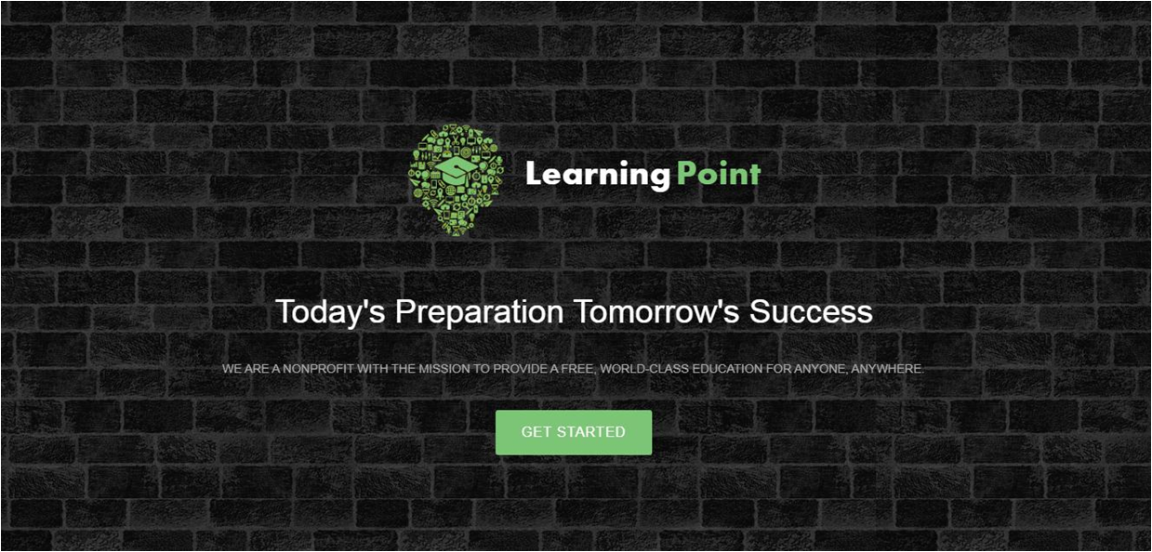

**About Page**

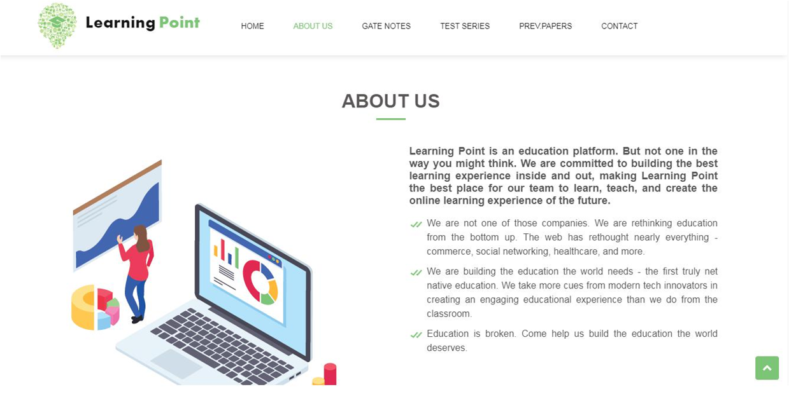

**Gate Notes Page**

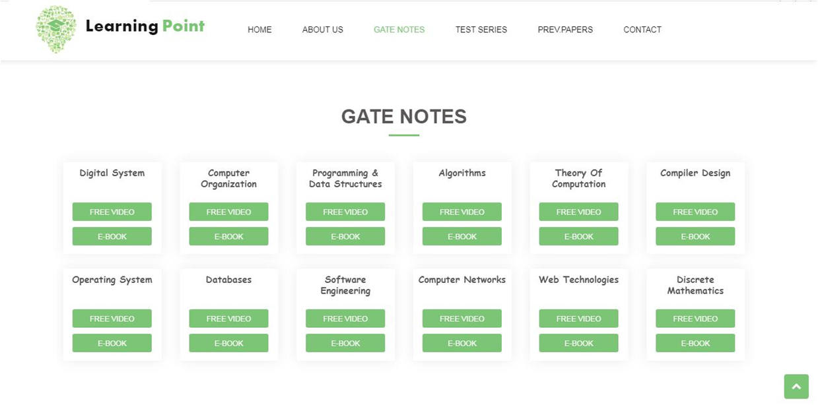

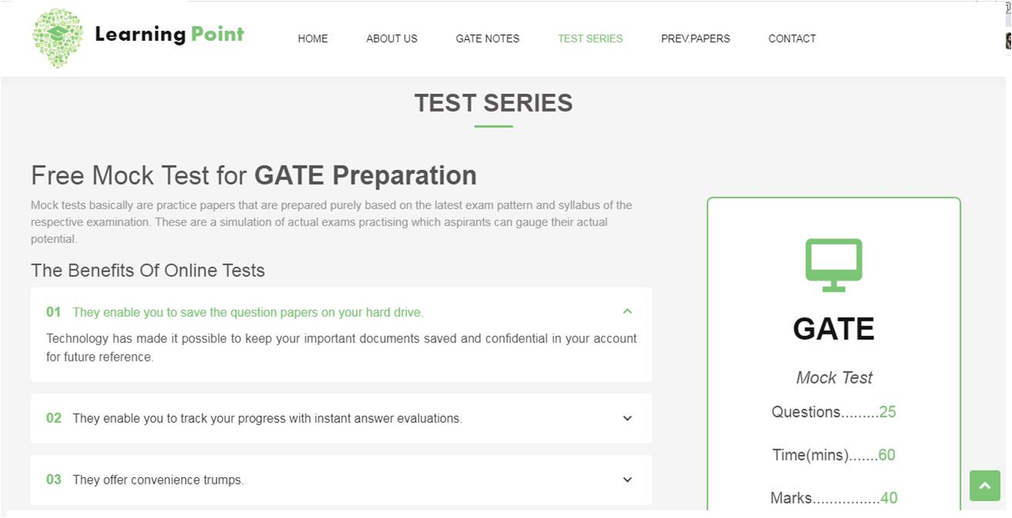

**Previous Year Papers Page**



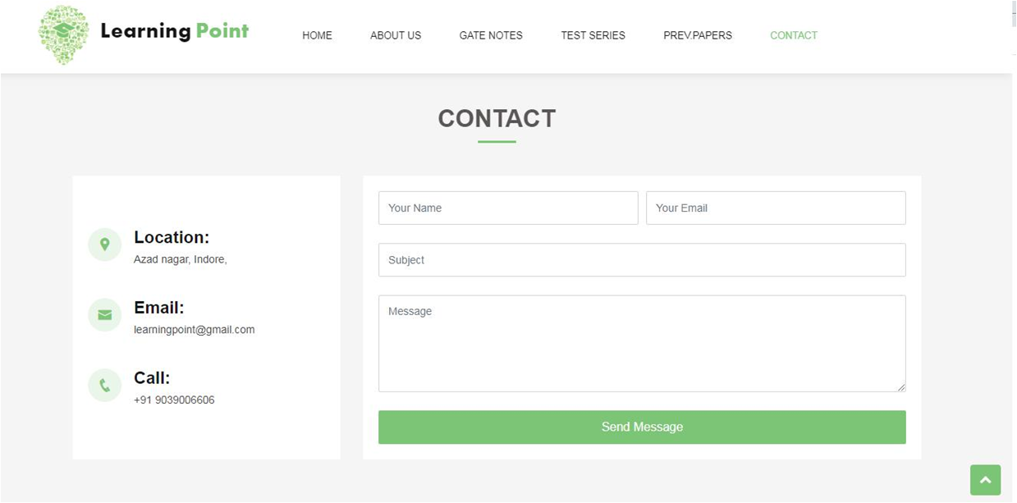

**Mock Test Instructions Page**

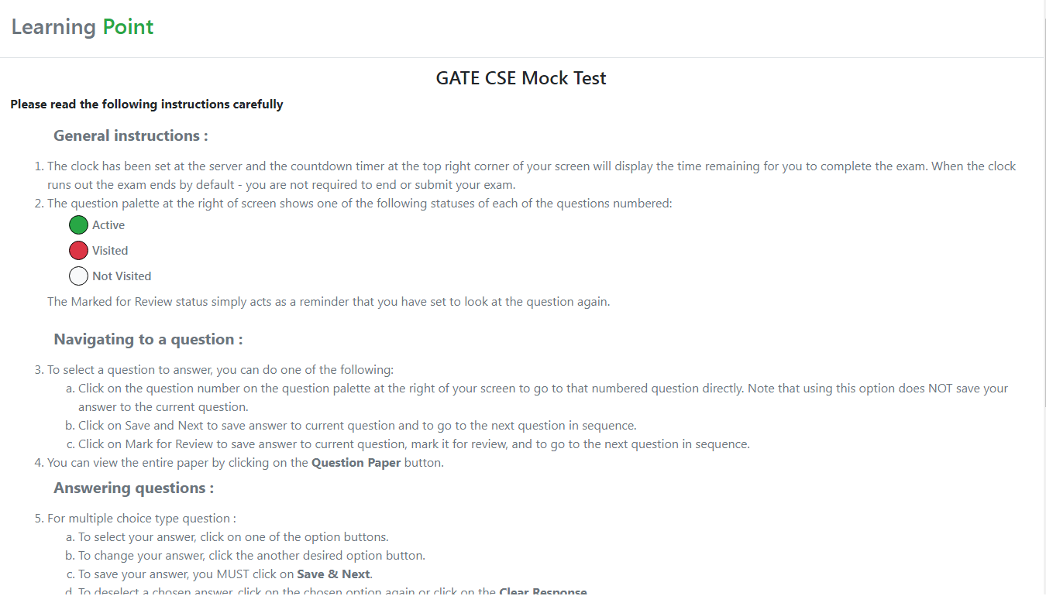

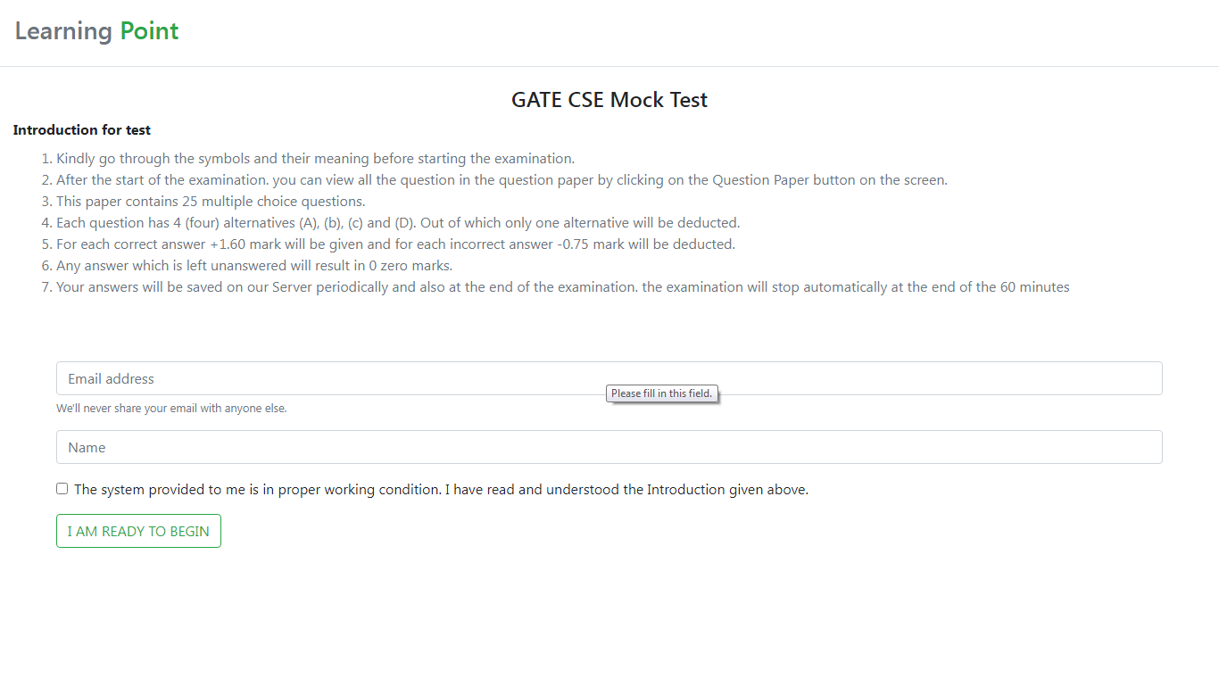

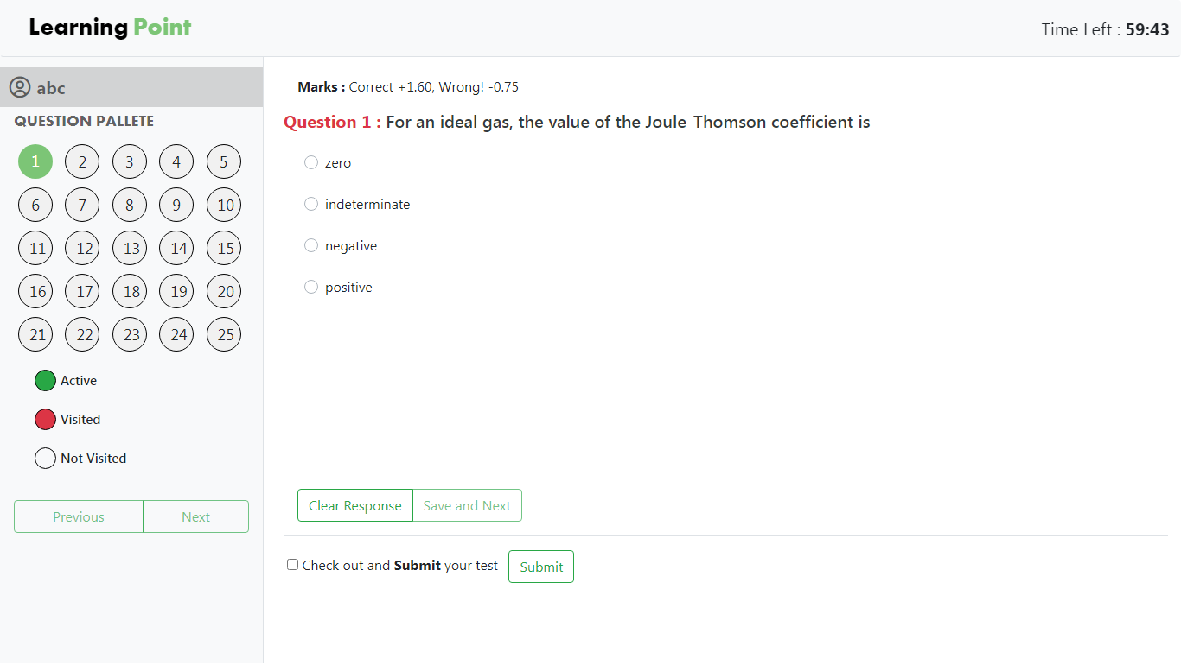

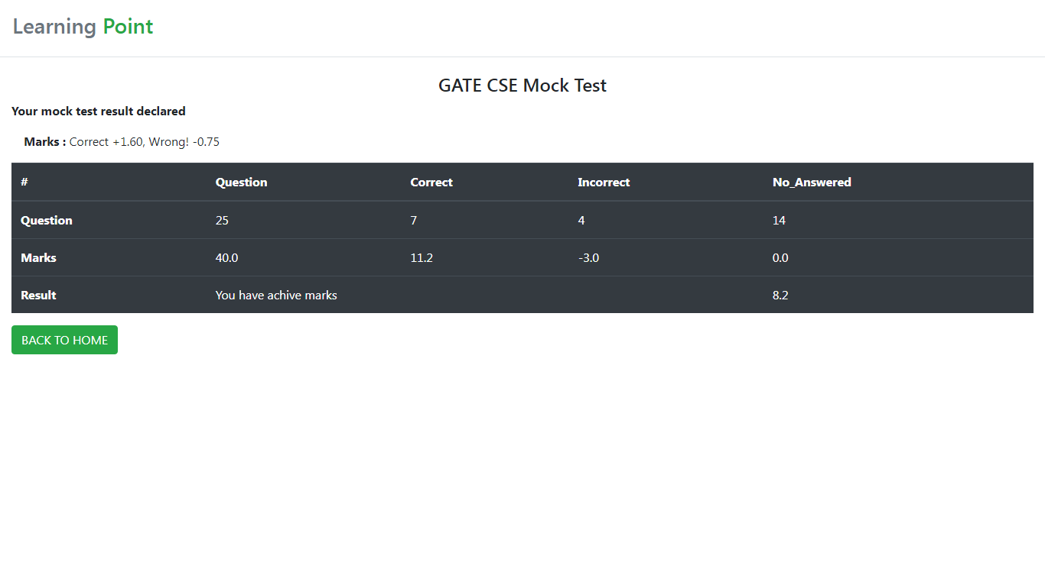

**CONCLUSION**

E-learning is not intended to replace conventional methods and learning in class rooms .Its aim to create an augmented learning environment where technologies is used to deliver a combined range of learning  and teaching techniques aimed to maximizing individual’s participation and achieving the goals in the learning and teaching process as a greener world

E-learning is not just a change of technology. It is part of a redefinition of how we as a species transmit knowledge, skills, and values to younger generations of workers and students. I will end this book by daring to make a few predictions of how e-learning and the functions it serves will continue to develop.

**REFERENCE**

1. www.google.com
2. www.student tutoria.com
3. www.w3school.com
4. www.stack overflow.com
5. www.roseindia.net
6. https://youtube code grid
7. https://youtube coding flag
8. http://www.wikipedia.com
9. http://www.Draw.io.com